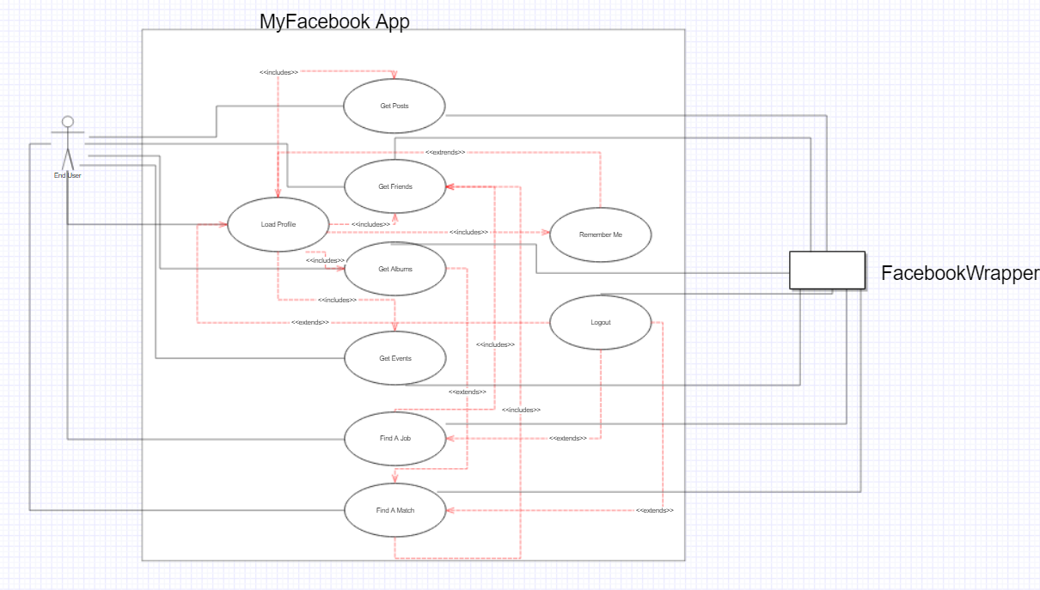

**Use Case Diagram**

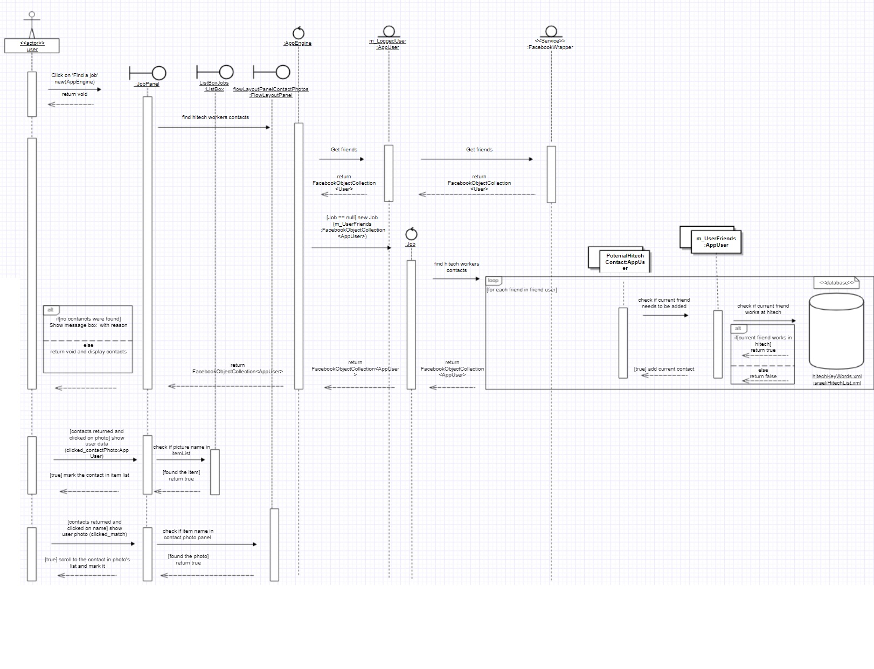

**Sequence Diagram- Job**

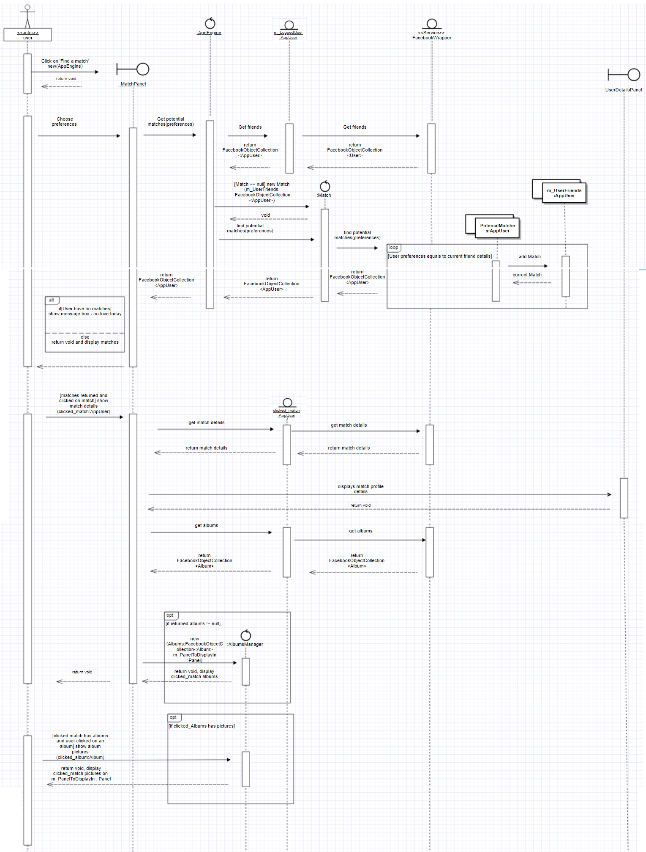

**Sequence Diagram- Match**

**Features Explenation**

Feature 1: find a job

Enables the user to find contacts that work in the hi-tech industry.

The system checks in database xml files we've included in the project if a friend of the user has one or more keywords / hi-tech company name in his work experience description.

If it finds such friends, it displays the friend name, work place and picture.

Can be found in PanelJob component which operates the AppEngine.

Feature 2: find a match

Enables the user to find friends that match his dating interests.

The system lets the user to choose preferences such as gender and age, it checks in the user friends if a friend is in the chosen gender and age range and if he/she available for relationship.

If it finds such friends, it displays the friend profile picture.

The user has an option to click on a friend profile picture and see its albums and personal details.

The user also can click on each album to view the album pictures and get to know this friend better.

Can be found in PanelMatch component which operates the AppEngine.

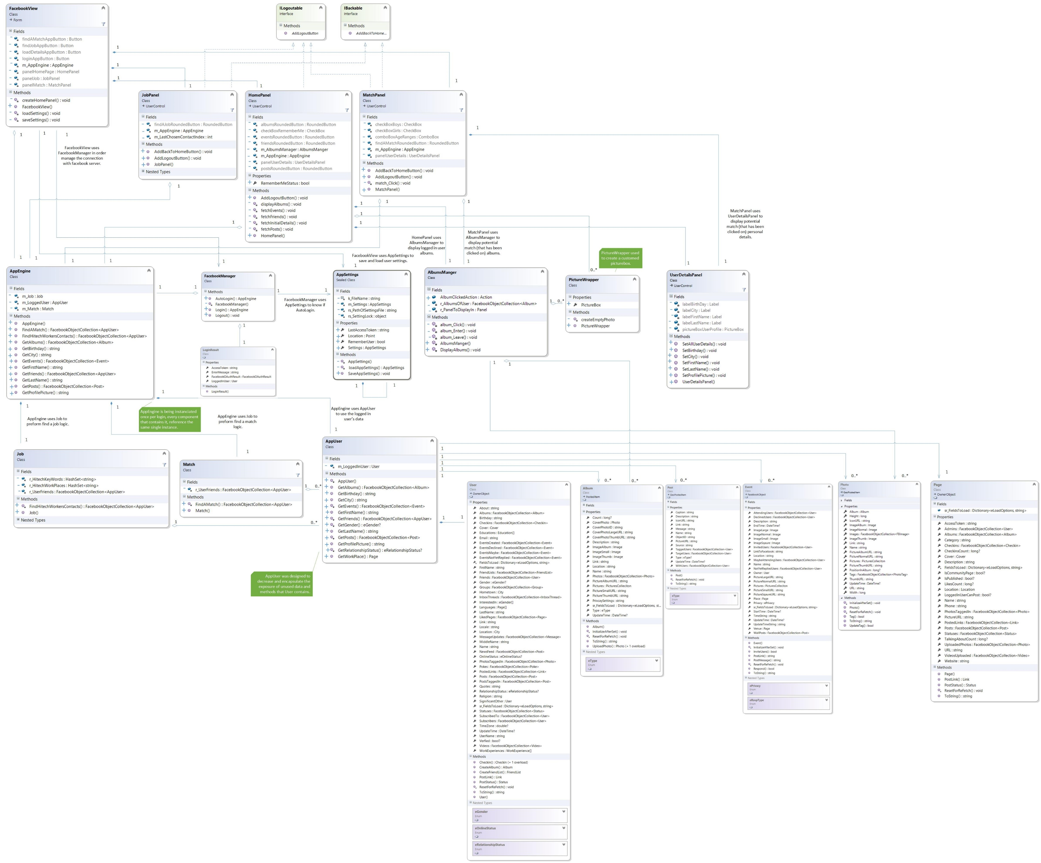

**Class Diagram**